Case Study:

How does a bike-share navigate speedy success?

Asher Harman

## Business Task

The initial [case study](https://drive.google.com/file/d/1tDLKeNR_JwEkytY4VUN7WCOXBtQfO2uM/view?usp=drive_link) explains the role of data analysis in assisting Cyclistic, a bike-sharing company. We will work under Divvy’s data [license](https://divvybikes.com/data-license-agreement).

Cyclistic has asked us to use the information provided over the last twelve months to answer the question, “How do annual members and casual riders use Cyclistic bikes differently?” for this up-and-coming bike-sharing company. We will use their [data repertoire](https://divvy-tripdata.s3.amazonaws.com/index.html) to find common trends and complete our task. We have been asked to use the twelve most recent months. They organize the datasets with the first four digits being the year and the last two numbers representing the year. For this case study, the datasets used will be 202307-divvy-tripdata through 202406-divvy-tripdata.

The Cyclistic company has asked for six deliverables in this report.

Deliverables:

1. A clear statement of the business task
2. A description of all data sourced used
3. Documentation of any clearing or manipulation of data
4. A summary of your analysis
5. Supporting Visualizations and Key Findings
6. Your top three recommendations are based on your analysis.

## Data Processing

We have datasets from Cyclists (Divvy’s) regarding where we will work. The original datasets each contain all of the information collected within a month. Each dataset has around twelve columns: the ride_id, rideable_type, started_at, ended_at, start_station, end_station, start_lat, start_lng, end_lat, end_lag, and memeber_casual. Fundamentally, the most important features are the individual ride_ids, started_at, ended_at, rideable_type, member_casual, and the latitude and longitude start and end locations. Primarily so that the CSV files can be placed into Google Sheets and edited further.

The first step is to remove the unnecessary columns. We will remove unnecessary or primarily empty columns. The four primary columns removed were the stations that started and ended, along with their IDs. The next step was to find the time each ride or bike was rented for. To do this, we created a column with the time duration format and used the formula of started_at - ended_at to calculate the duration of each ride. The next column that was added is the day of the week. We used the WEEKDAY(started_at,1) formula to discover this. This returned the day of the week with 1 = Sunday through 7 = Saturday.

## 

## Analysis

To examine Cyclist's overall growth and trends, we've taken the oldest and newest periods in a year to compare their totals, the average ride length separated by day of the week, and whether they were Cyclist members or casual users. The first table is that of June 2023, with the second being July 2024.

202306-divvy-tripdata

|  | *Day of Week* | | | | | | | | | | | | | | | |
| --- | --- | --- | --- | --- | --- | --- | --- | --- | --- | --- | --- | --- | --- | --- | --- | --- |
|  | Sunday | | Monday | | Tuesday | | Wednesday | | Thurday | | Friday | | Saturday | | Grand Total | |
| Membership Status | Avg Ride Leng | # of Rides | Avg Ride Leng | # of Rides | Avg Ride Leng | # of Rides | Avg Ride Leng | # of Rides | Avg Ride Leng | # of Rides | Avg Ride Leng | # of Rides | Avg Ride Leng | # of Rides | Avg Ride Leng | # of Rides |
| casual | 0:32:43 | 41624 | 0:29:04 | 32269 | 0:23:48 | 24955 | 0:25:39 | 33748 | 0:24:32 | 42917 | 0:29:51 | 56422 | 0:34:05 | 69295 | 0:29:24 | 301230 |
| member | 0:14:20 | 42451 | 0:12:32 | 53016 | 0:12:13 | 51485 | 0:12:26 | 61089 | 0:12:36 | 74274 | 0:13:14 | 74736 | 0:15:17 | 61337 | 0:13:12 | 418388 |
| **Grand Total** | **0:23:26** | **84075** | **0:18:47** | **85285** | **0:16:00** | **76440** | **0:17:08** | **94837** | **0:16:58** | **117191** | **0:20:23** | **131158** | **0:25:15** | **130632** | **0:19:59** | **719618** |

When we look at the trends for June 2023, we can see a more significant number of members than the casual user, with approximately 58% of users being members. Another interesting feature I noticed immediately is that, on average, casual riders ride for approximately half an hour, while members generally ride for less than fifteen minutes. While the general spread of people who use Cyclist keeps a consistent line both for casual and members that this is a downtime activity and that as time progressed through a week, the userbase of Cyclist increased. However, the average bike times stayed consistent for Friday, Saturday, and Sunday.

Totaling all users, the most popular days to use Cyclist are Saturday and Sunday, with an average bike riding time of approximately twenty minutes.

202405-divvy-tripdata

|  | *Day of Week* | | | | | | | | | | | | | | | |
| --- | --- | --- | --- | --- | --- | --- | --- | --- | --- | --- | --- | --- | --- | --- | --- | --- |
|  | Sunday | | Monday | | Tuesday | | Wednesday | | Thursday | | Friday | | Saturday | | Grand Total | |
| Membership Status | Avg Ride Leng | # of Rides | Avg Ride Leng | # of Rides | Avg Ride Leng | # of Rides | Avg Ride Leng | # of Rides | Avg Ride Leng | # of Rides | Avg Ride Leng | # of Rides | Avg Ride Leng | # of Rides | Avg Ride Leng | # of Rides |
| casual | 0:32:43 | 34501 | 0:27:36 | 24313 | 0:22:54 | 19780 | 0:24:06 | 33571 | 0:23:05 | 28828 | 0:26:52 | 39527 | 0:32:03 | 50498 | 0:27:44 | 231018 |
| member | 0:14:56 | 37894 | 0:13:15 | 43122 | 0:12:34 | 47900 | 0:13:07 | 73264 | 0:12:36 | 61980 | 0:13:06 | 64074 | 0:15:34 | 50241 | 0:13:29 | 378475 |
| **Grand Total** | **0:23:24** | **72395** | **0:18:25** | **67435** | **0:15:35** | **67680** | **0:16:34** | **106835** | **0:15:56** | **90808** | **0:18:21** | **103601** | **0:23:50** | **100739** | **0:18:53** | **609493** |

In May 2024, the trends remained relatively similar, but the numbers deflated. Fewer users of the Cyclist app exist, and the average ride lengths for members and casuals appear relatively identical. The number of people and the average time a bike has decreased. The rest of the trends remained the same as in June 2023.

## Visualizations

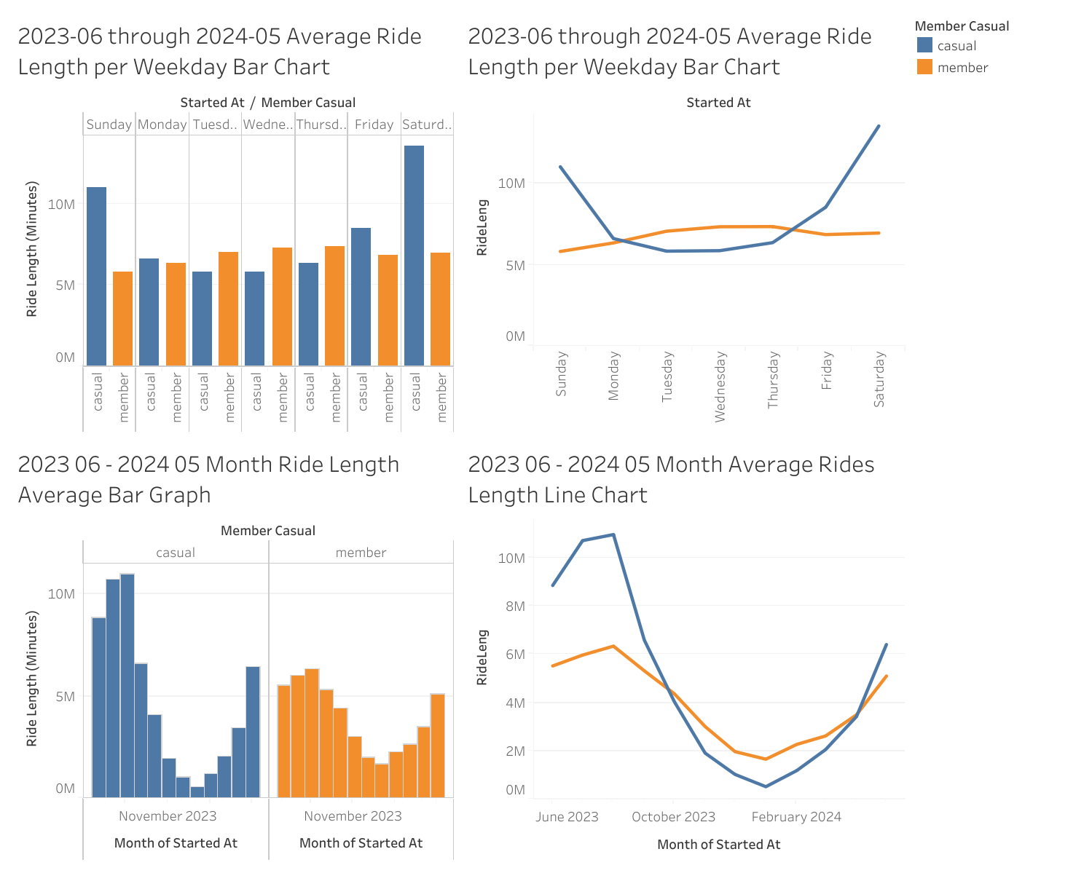

## Recommendations

* Provide discounted prices for the winter months to increase the number of individuals who raise the bikes during that period.
* Lower staff working hours during winter months are less costly for the company.
* Since members have a more consistent degree of numbers throughout the week, it might be a good idea to work on bringing individuals to convert casual riders to members. Additional discounts or bonuses are given for the time the bike was ridden.